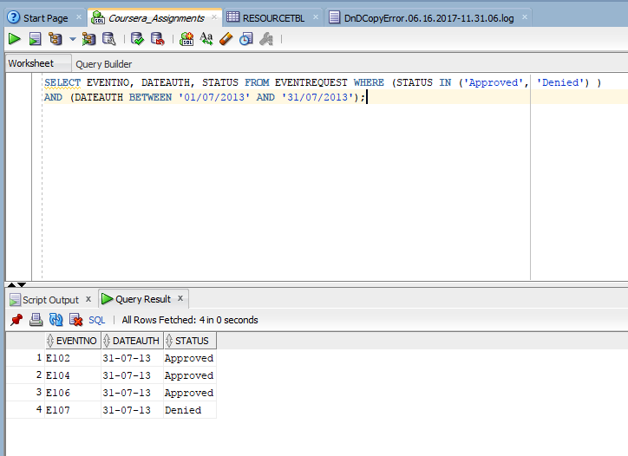
SELECT EVENTNO, DATEAUTH, STATUS FROM EVENTREQUEST WHERE (STATUS IN (‘Approved’, ‘Denied’)) AND (DATEAUTH BETWEEN ‘-0/07/2013’ AND ‘31/07/2013’);

